1. Login to Dynatrace Environment  
     
   <https://dxcdynatrace.sso.us.platform.dxc.com/e/9d80b705-282e-4cc5-b5ac-28db81d7d390/ui/dashboards?gtf=-2h&gf=all>
2. Left Side, under **Manage** click on **Settings**

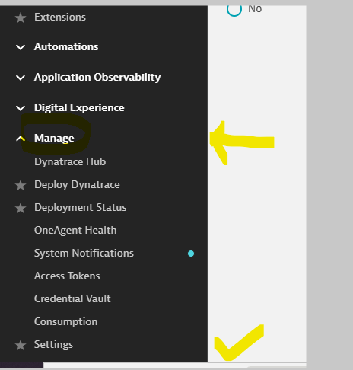

1. Once you click on settings, you will see an option for **Maintenance windows**  
     
   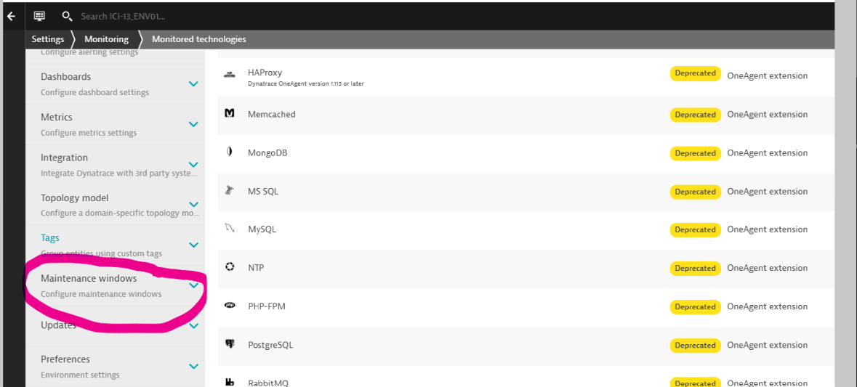
2. Under that, click on **Monitoring, alerting and availability**

You can see the page like below  
  
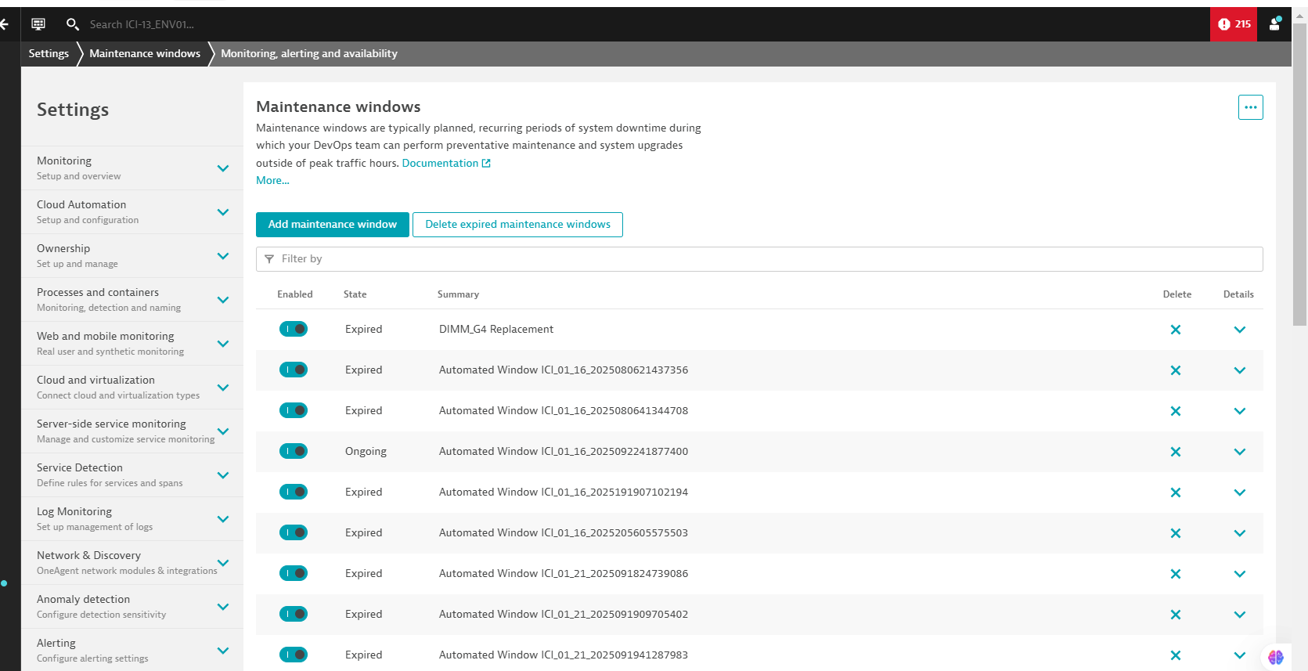

1. Click on **Add maintenance window** to create a new maintence window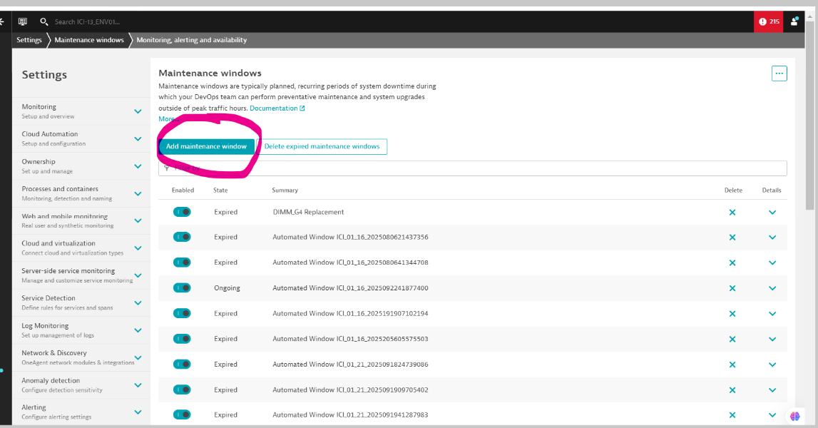
2. Fill the details   
   Name: You can give any name  
   Description: Optional  
   Maintenance type: Planned  
   Problem detection and alerting: Disable problem detection during maintenance  
   Recurrence: Once  
   Start time: when to start  
   End time: when to end  
   Timezone: timezone like MST, IST etc..
3. After filling above details, Under **Filters** click on **Add filter**  
     
   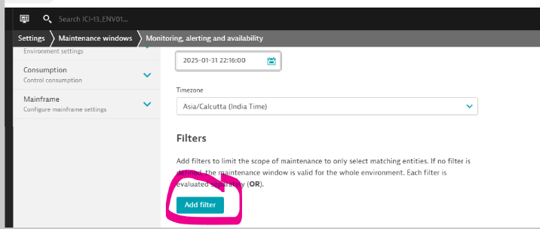

Fill the details:  
  
Entity type: SQL Server Instance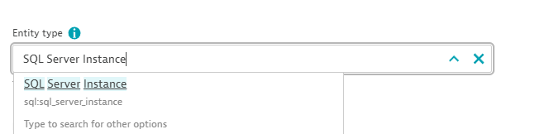  
  
Entity: SQL Server Instance  
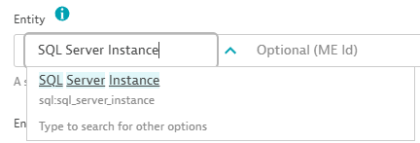

You can select any one SQL Server Instance from the dropdown box or type the instance name in the **Optional (ME Id)** field  
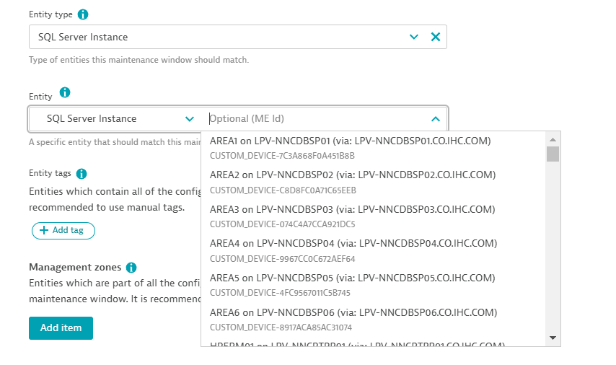

1. You will see like this  
     
   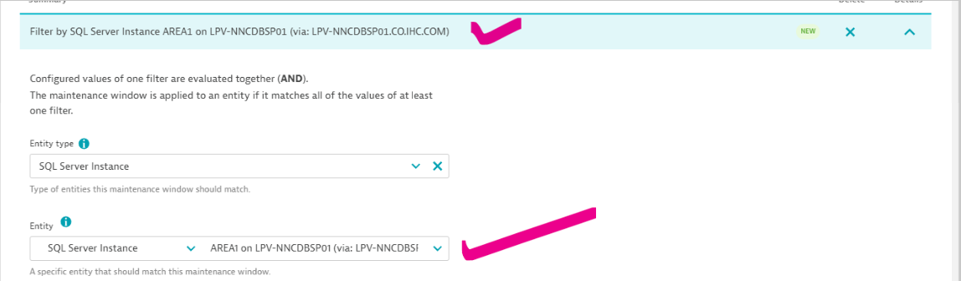
2. Click on **Add filter** again  
     
   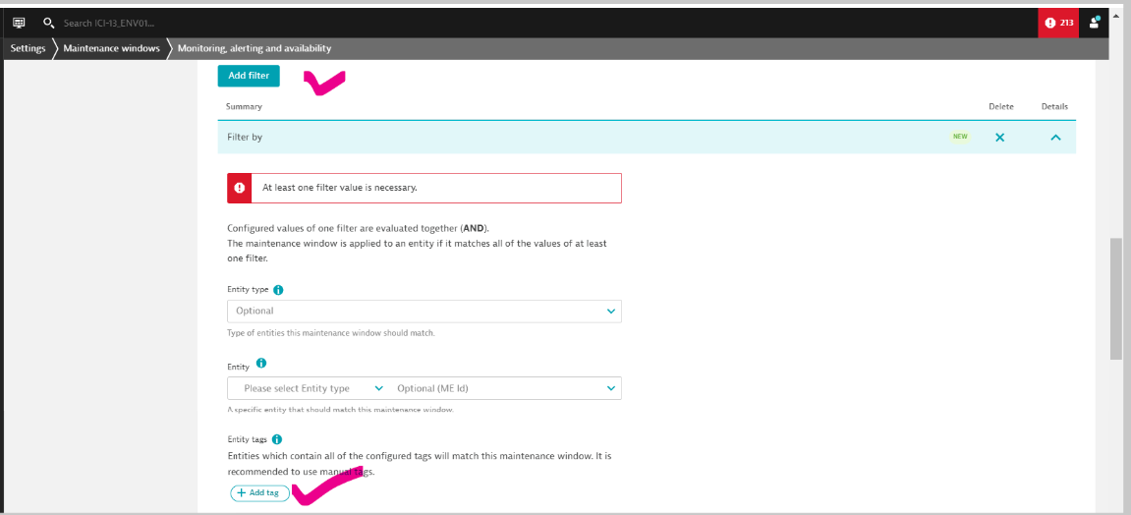
3. Click on the **Add tag,** fill the details   
   Show suggestions for entity type: SQL Server Instance  
   Key: **customProperties_Node_IP**Value: **Primary IP of that particular server or host**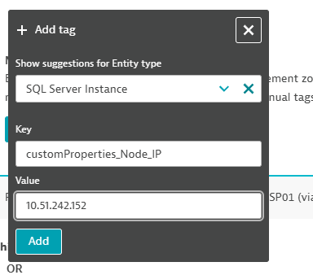
4. After filling click on **Add**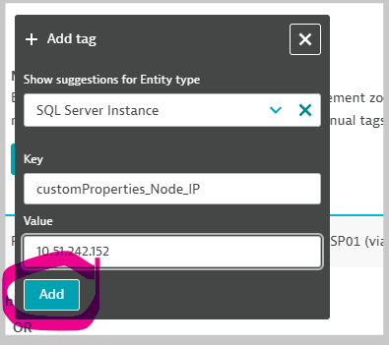
5. You have applied 2 filters and you can see like this  
     
   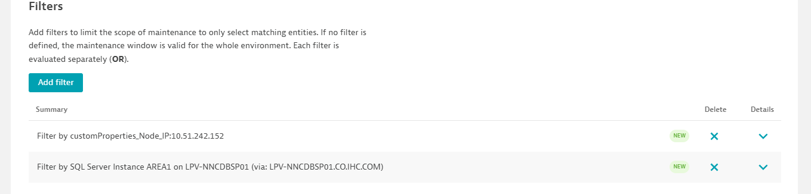
6. You need to add 2 filters like above for each SQL Server Instance.   
   If you are creating a single maintenance window for 3 SQL Server Instances (A, B, C) then you need to add a total of 6 filters
7. Save the changes, left side bottom   
     
   